Project Title – Airfare Price Prediction Using Machine Learning
1. Industry Review
1.1 Current Practices & Background
The U.S. commercial aviation industry relies on complex, dynamic pricing strategies known as Revenue Management Systems (RMS). Airfare prices for similar routes vary significantly based on factors such as flight distance, passenger demand, airline market share, and seasonal travel patterns. Currently, these pricing algorithms are "black boxes," leaving travelers and policy analysts without transparent insights into why fares fluctuate. While airlines use internal forecasting tools to maximize revenue, there is a lack of consumer-facing tools that estimate "fair market value" based on route characteristics.

1.2 Literature Survey
To ground our research, we reviewed key studies in aviation economics and predictive modeling:
- Borenstein & Rose (1994): Their research highlighted that airfare is driven not just by cost (distance/fuel) but significantly by Market Concentration. They found that "hub dominance" allows airlines to charge premium prices, a theory we validate in our EDA.
- Wang et al. (2019): This study utilized the DB1B and T-100 datasets to demonstrate that Machine Learning models (specifically Gradient Boosting) outperform traditional linear econometric models in predicting airfare.
- Prasad et al. (2020): Their work confirmed that ensemble methods like Random Forest and XGBoost are effective for ticket price prediction, achieving higher accuracy than single-model approaches. This supports our decision to move towards these models in Phase 2.

2. Dataset and Domain
2.1 Data Source
The dataset is the U.S. Consumer Airfare Report (Table 1a), published by the U.S. Department of Transportation (Bureau of Transportation Statistics). It provides quarterly data on average fares, passenger volumes, and market shares for U.S. airport-pair markets.
2.2 Data Dictionary
The dataset includes 18 features representing route and carrier characteristics.
Variable Categorization:
Variable | Type | Description
fare | Numeric (Target) | Average passenger fare for the route ($).
nsmiles | Numeric | Non-stop distance in miles.
passengers | Numeric | Average number of passengers per day.
large_ms | Numeric | Market share of the largest carrier (0.0 - 1.0).
fare_lg | Numeric | Average fare of the largest carrier.
lf_ms | Numeric | Market share of the low-fare carrier.
fare_low | Numeric | Average fare of the low-fare carrier.
carrier_lg | Categorical | Airline code for the largest carrier (e.g., AA, DL).
carrier_low | Categorical | Airline code for the low-fare carrier.
airport_1 | Categorical | Origin Airport Code.
airport_2 | Categorical | Destination Airport Code.

2.3 Alternate Sources of Data
To supplement the core dataset in the final phase, we have identified:
- Skytrax Reviews: Qualitative passenger sentiment data to account for service quality impacts on price.
- US Holiday Calendar: Boolean features flagging federal holidays to capture peak travel seasonality.
3. Pre-Processing Data Analysis
3.1 Missing Value Analysis
We performed a null check on the raw dataset.
- Observation: Core numerical columns (nsmiles, passengers) were clean. Market share columns contained minor missing values (<1%).
- Treatment:
  - Numerical Features: Imputed using the Median strategy to ensure robustness against outliers.
  - Categorical Features: Imputed using the Mode.
3.2 Redundant Columns & Data Leakage
- Dropped Columns: Geocoded_City1 and Geocoded_City2 were removed as they contained redundant geographical information covered by Airport Codes.
- Leakage Prevention (Critical Step): We identified fare_lg (Fare of Largest Carrier) and fare_low (Fare of Low-Cost Carrier) as potential data leakage, as they are direct components of the average fare. These variables were removed to ensure the model predicts price based on route characteristics (distance, competition) rather than simply "copying" a correlated fare column.

4. Project Justification
4.1 Project Statement
"To develop a Machine Learning system that predicts the average fair market price for domestic flights and identifies the key cost drivers (e.g., Monopoly Power vs. Distance)."
4.2 Complexity Involved
The primary complexity lies in Non-Linearity. A short-haul flight can be more expensive than a long-haul flight if the route is a monopoly. Simple linear equations cannot capture this dynamic. Additionally, the High Cardinality of airport codes requires careful feature engineering.
4.3 Project Outcome
- Social Value: Provides price transparency to travelers, helping them identify overpriced tickets.
- Commercial Value: Helps new airline entrants benchmark their pricing strategies against established competitors.

5. Data Exploration (EDA)
5.1 Univariate Analysis
- Target Variable (fare): The fare distribution is slightly right-skewed, with most tickets costing between $150 and $300.
- Passenger Demand: The passengers variable is highly skewed, indicating that a small number of popular routes (e.g., JFK-LAX) carry the bulk of traffic.
5.2 Relationship Between Variables
- Distance vs. Price: We observed a positive but weak correlation (~0.58) between distance (nsmiles) and fare. This confirms that while distance adds cost, it is not the sole driver of price.
- Market Share vs. Price: Routes where a single airline has >70% market share (large_ms) tend to have significantly higher fares, validating the "Monopoly Premium" theory.
5.3 Outlier Treatment
- Method: Interquartile Range (IQR).
- Action: Outliers in fare and passengers (values > $Q3 + 1.5*IQR$) were capped. This ensures the model learns from typical commercial flights rather than rare luxury charters.

6. Feature Engineering
6.1 Transformations
- Log Transformation: Applied to passengers to normalize its skewness, making the data distribution Gaussian for better regression performance.
6.2 Feature Creation
- competition_ratio: Created a new feature (large_ms / lf_ms) to quantify the dominance of the market leader over low-cost competitors.
- route_id: Concatenated airport_1 and airport_2 to capture route-specific signatures.
6.3 Scaling
- StandardScaler: Applied to numerical features (nsmiles, passengers) to standardize them (Mean=0, Std=1), ensuring distance (0-3000) doesn't dominate market share (0-1) during model training.
7. Assumptions (Baseline Model)
We defined this as a Supervised Regression problem. We trained a Multiple Linear Regression model to establish a performance benchmark.
7.1 Assumptions Checked
- Linearity: Assumed a linear relationship between features and target (EDA suggests this is weak).
- No Multicollinearity: Variance Inflation Factor (VIF) checks were conducted; high VIF variables were removed.
- Homoscedasticity: Residual plots were examined to ensure constant variance of errors.
7.2 Baseline Results
- R-Squared Score: 0.58 (58%)
- Inference: The baseline model explains only 58% of the variance. This low score mathematically confirms that airfare pricing is Non-Linear. A simple linear equation cannot capture complex interactions like market monopoly.
- Conclusion: This result justifies the need for advanced Tree-Based Ensembles (Random Forest, XGBoost) in the next phase.

8. Future Scope (Phase 2 Roadmap)
Having established the baseline, the final phase of the project will focus on:
- Advanced Modeling: Implementing Random Forest and XGBoost to capture the non-linear market dynamics identified in EDA.
- Hyperparameter Tuning: Using RandomizedSearchCV to optimize model parameters for maximum accuracy.
- GenAI & Chatbot: Developing a Travel Assistant Chatbot (using NLP) to allow users to query fare predictions and summarize route sentiment.
- Deployment: Building a Streamlit Web Application to serve these predictions to end-users in real-time.

Project Details

OVERVIEW:
Airfare prices in the U.S. vary significantly across different airport routes due to multiple factors such as flight distance, passenger demand, airline competition, market size, and seasonal travel patterns. Understanding these variations is essential for airlines, policymakers, and travelers who rely on accurate pricing insights for planning and decision-making. This project uses the Consumer Airfare Report dataset, which contains detailed information about U.S. airport-pair markets, to analyze pricing behavior and identify key factors that influence airfare. By applying exploratory data analysis and machine learning techniques, the project aims to develop a predictive model capable of estimating airfare for any given route and generating valuable insights into the dynamics of airline pricing.

Business problem statement (GOALS)
- Business Problem Understanding
Airfare pricing is a complex and dynamic process. Airlines change fares based on operational costs, route distance, competition, seasonal trends, passenger demand, and revenue-management algorithms. These pricing models are proprietary and not publicly available.
This lack of transparency causes challenges:
- Travelers cannot estimate whether ticket prices are fair or overpriced.
- Travel agencies struggle with route planning and price forecasting.
- Airlines cannot easily compare competitiveness across markets.
- Policymakers lack data to analyze market fairness

- Business Objective
The primary business objective of this project is to predict the average airfare price for any U.S. airport route and identify the major factors influencing these prices. Since airfare frequently fluctuates due to factors such as distance, passenger demand, seasonal trends, and airline competition, it becomes challenging for stakeholders—including airlines, travel companies, and passengers—to make informed decisions.
This project utilizes the Consumer Airfare Report dataset to develop a transparent, data-driven predictive system that helps users understand airfare behavior and supports better decision-making.

- Approach
- Explore and clean the Consumer Airfare dataset
- Analyze route characteristics and pricing behaviour
- Engineer meaningful features such as fare-per-mile and seasonal trends
- Build machine learning regression models to predict airfare
- Interpret key factors influencing fare variations

- Conclusions
The project aims to deliver a predictive system capable of estimating airfare for any U.S. route and provide data-driven insights into pricing behavior, helping stakeholders make optimized business decisions.

TOPIC SURVEY
- Problem understanding
Airfare prices change often because of distance, demand, season, airline competition, and other travel costs. These frequent changes make it hard for people to understand why prices go up or down. Airlines use advanced pricing systems to decide fares, but these systems are very expensive, difficult to maintain, and not available to the public.
Because of this, passengers cannot plan their travel properly, travel companies find it hard to give accurate price suggestions, and analysts cannot judge if prices are fair. The high cost of using and maintaining airline pricing systems also creates a big problem.
To solve this, we need a simple, low-cost, data-driven model that studies the factors affecting prices and predicts airfare clearly. This will help all users make better decisions.

- Current solution to the problem
Existing pricing systems primarily rely on airline revenue management algorithms, historical fare data, and competitive positioning. However, these systems are proprietary and not openly shared. Public research typically focuses on descriptive analysis of airfare trends, with fewer studies applying machine learning to forecast fare values using large-scale route-level datasets.

- Proposed solution to the problem
This project proposes a predictive modeling approach using machine learning to estimate airfare prices based on route characteristics. By leveraging the U.S. Consumer Airfare Report dataset, the project identifies determinants such as distance, quarterly seasonality, passenger volume, airport pair, and carrier influence. Regression models such as Linear Regression, Random Forest, and Gradient Boosting will be applied to generate accurate predictions.

- Reference to the problem
Real-world studies, airline market reports, and government aviation statistics highlight substantial variation in airfare patterns. Publicly available datasets (e.g., BTS Consumer Airfare Report) provide rich information useful for building predictive models and understanding pricing economics. This project extends that foundation using ML techniques

CRITICAL ASSESSMENT OF TOPIC SURVEY
- Find the key area, gaps identified in the topic survey where the project can add value to the customers and business?
The topic survey reveals that while airfare data is publicly available, most analyses focus on historical trends rather than providing forward-looking insights. Airlines often use internal, proprietary pricing systems, leaving customers and policymakers with limited visibility into why fares change across routes. This project adds value by creating a transparent, data-driven prediction model that helps customers anticipate price patterns and enables businesses, especially airlines and travel agencies, to make informed decisions on pricing strategies, demand forecasting, and competitive analysis.

- What key gaps are you trying to solve?
The major gaps identified include the lack of accessible predictive models for airfare estimation, limited research applying machine learning to route-level airfare data, and an absence of clear explanations for the factors influencing fare variations. This project addresses these gaps by developing an interpretable machine learning framework that predicts airfare and highlights the most significant drivers of pricing. The goal is to bridge the knowledge gap and provide actionable insights for users who currently rely on guesswork or non-transparent fare systems.

METHODOLOGY TO BE FOLLOWED

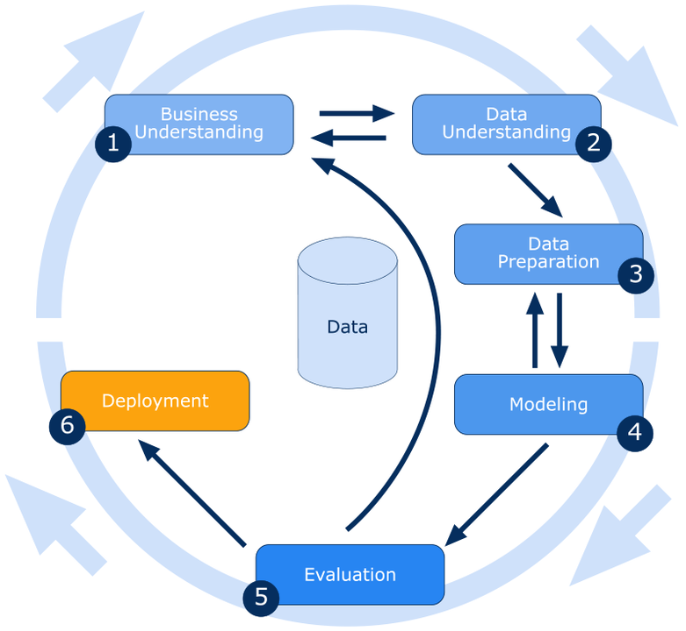
- Business Understanding
The objective of this project is to predict airfare prices for U.S. airport routes and understand the factors that drive pricing variations. From a business point of view, this project supports three major groups. Airlines can use the insights to study route performance and improve their pricing decisions. Travel platforms and agencies gain a clearer understanding of market patterns, helping them guide customers more accurately. Policymakers can use the findings to review whether pricing practices are fair across different markets.

- Data Understanding
The dataset used in this project is the U.S. Consumer Airfare Report, which provides detailed route-level airfare information across the United States.
During data understanding, the dataset was checked for:
- Shape of the data (255,780 rows × 23 columns)
- Variable types (numerical, categorical, identifiers)
Numerical variables:
Year, quarter
nsmiles (route distance)
passengers (number of travelers)
fare (average airfare)
large_ms (market share of the largest carrier)
fare_lg, lf_ms, fare_low (additional fare and market share information)
Categorical variables:
Year, quarter
city1, city2
airport_1, airport_2
carrier_lg, carrier_low
Geocoded_City1, Geocoded_City2
Identifier variables:
citymarketid_1, citymarketid_2
airportid_1, airportid_2
tbl, tbl1apk

- Summary statistics:

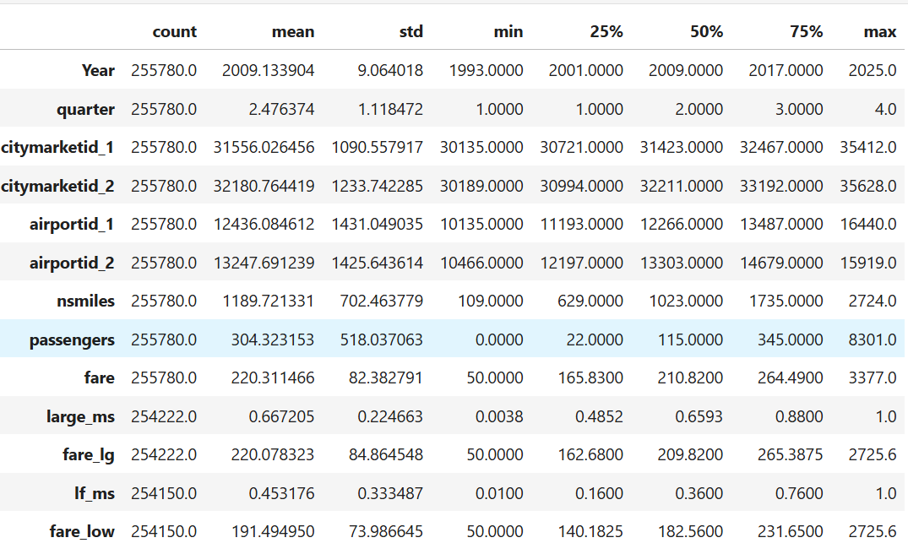

- Data Preparation
The Data Preparation stage ensures that the dataset is clean, consistent, and ready for analysis and model building. The following steps were performed:
- Handling Missing Values:
The dataset contained missing values in several columns such as carrier_lg, large_ms, fare_lg, carrier_low, lf_ms, fare_low, and geocoded location fields.
- Mean/Median for numerical columns.
- Mode for categorical variables
- Columns like Geocoded_City1 and Geocoded_City2 had extremely high null counts, so they were dropped to avoid noise and reduce dimensionality.

- Detecting and Treating Outliers:
Outliers create skewed distributions and affect model performance.
Steps Performed
- Used boxplots and IQR method for outlier detection.
- Outliers were treated by:
Capping extreme values at upper/lower bounds

- Encoding Categorical Variables:
Machines learning models only accept numerical values.
Categorical variables such as airport codes, carriers, city identifiers must be converted to numeric format.
Why Encoding is Required?
- Algorithms cannot understand text like "ATL", "JFK", or "DL"
- Encoding preserves the information in numerical form
- Helps models learn patterns without interpreting categories incorrectly
Methods Used
- Label Encoding for ordinal or high-cardinality categorical variables
- One-Hot Encoding for nominal variables such as airport IDs
- Exploratory Graph Analysis:
To understand variable distribution and relationships:
- Distribution of Continuous Variables (Univariate Analysis):
Plotted histograms (show distribution), and
boxplots (show outliers + spread)
for (Fare, passengers, nsmiles)

Purpose:
To observe normality, skewness, and outliers.
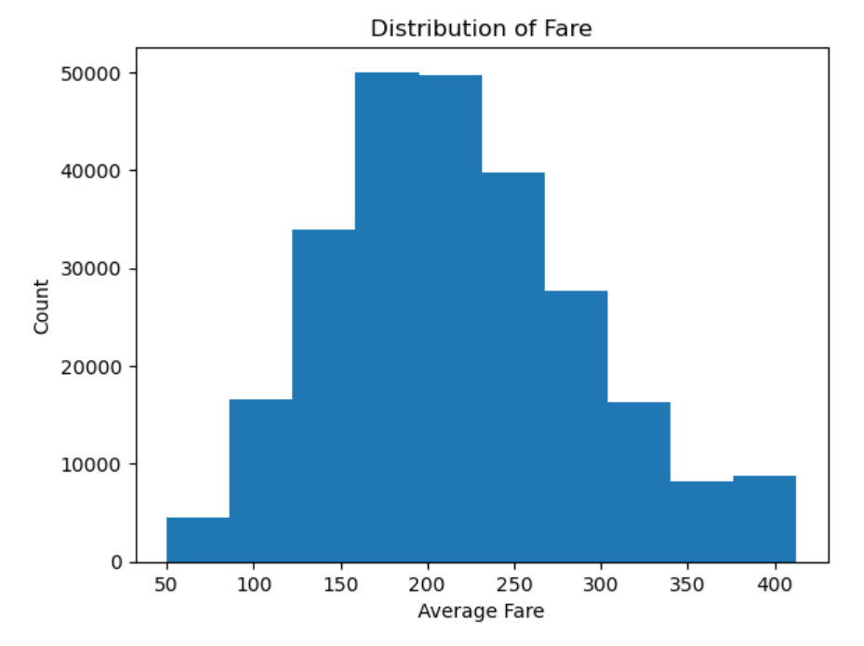
Purpose:
To see the distribution of fare and detect outliers so I can prepare the data properly for modeling.
It shows most fares fall between 150–250, very few are extremely high or low, and the distribution looks slightly spread with some outliers at the high end.

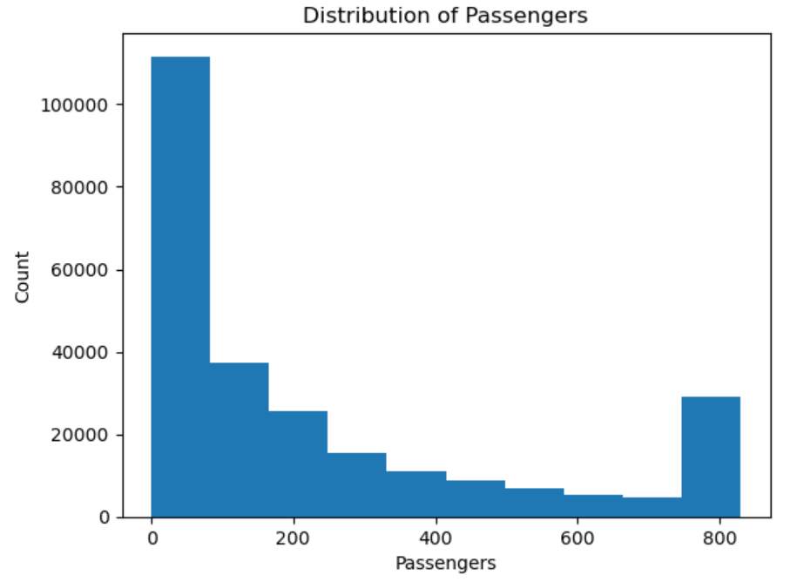
Purpose:
Count represents the number of records that fall within each passenger range.
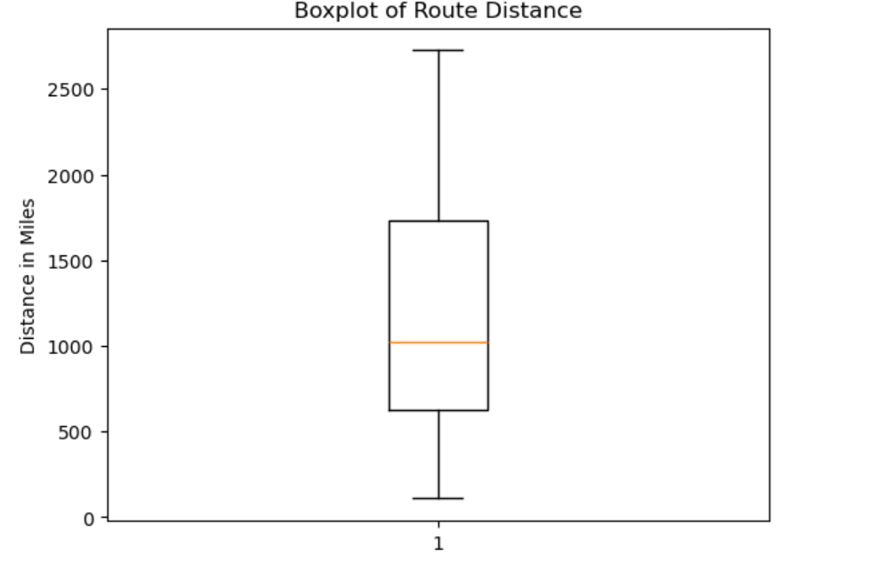
Purpose:
To detect outliers in route distance and understand how distances vary across U.S. flight routes.

- Scatterplots for Relationships (Bivariate Analysis):
Created scatterplots between key numerical columns such as:
- nsmiles(distance) vs fare
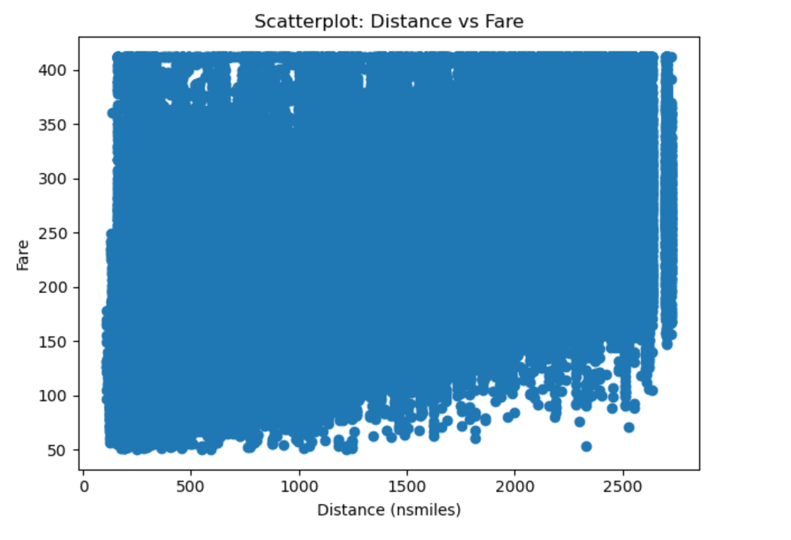

Purpose:
To understand how airfare changes with travel distance.
This helps identify patterns such as:
- whether longer routes have higher fares
- whether the relationship is linear or nonlinear
- presence of cost anomalies for certain distances

- fare vs passengers:

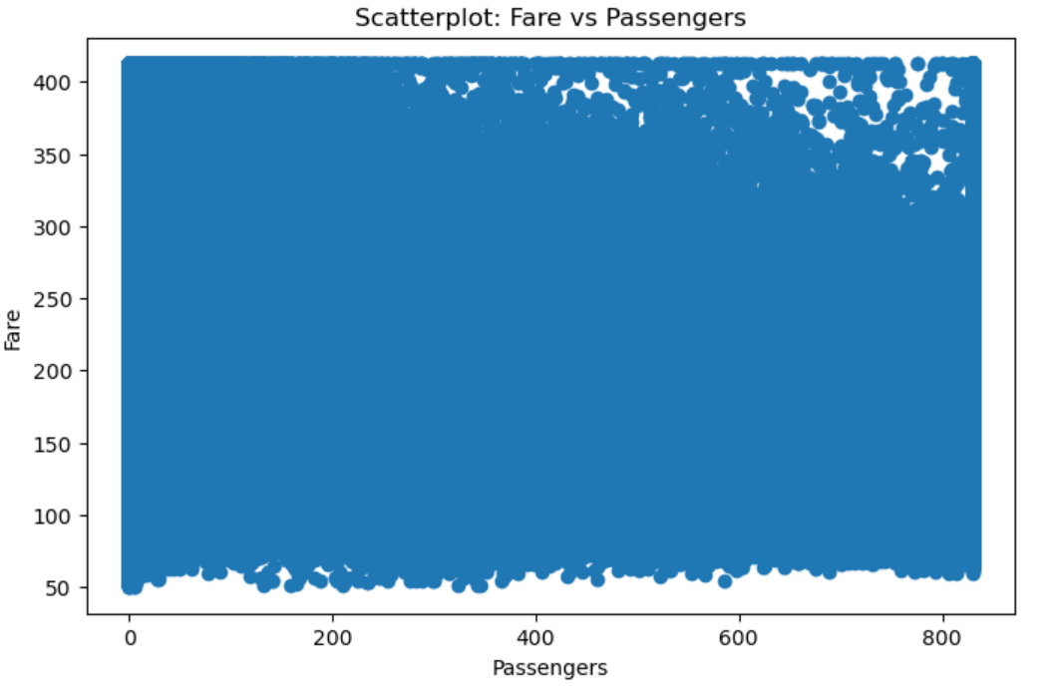
Purpose:
- Shows how fare changes with the number of passengers
- Helps identify trends or patterns

- carrier_lg vs fare:
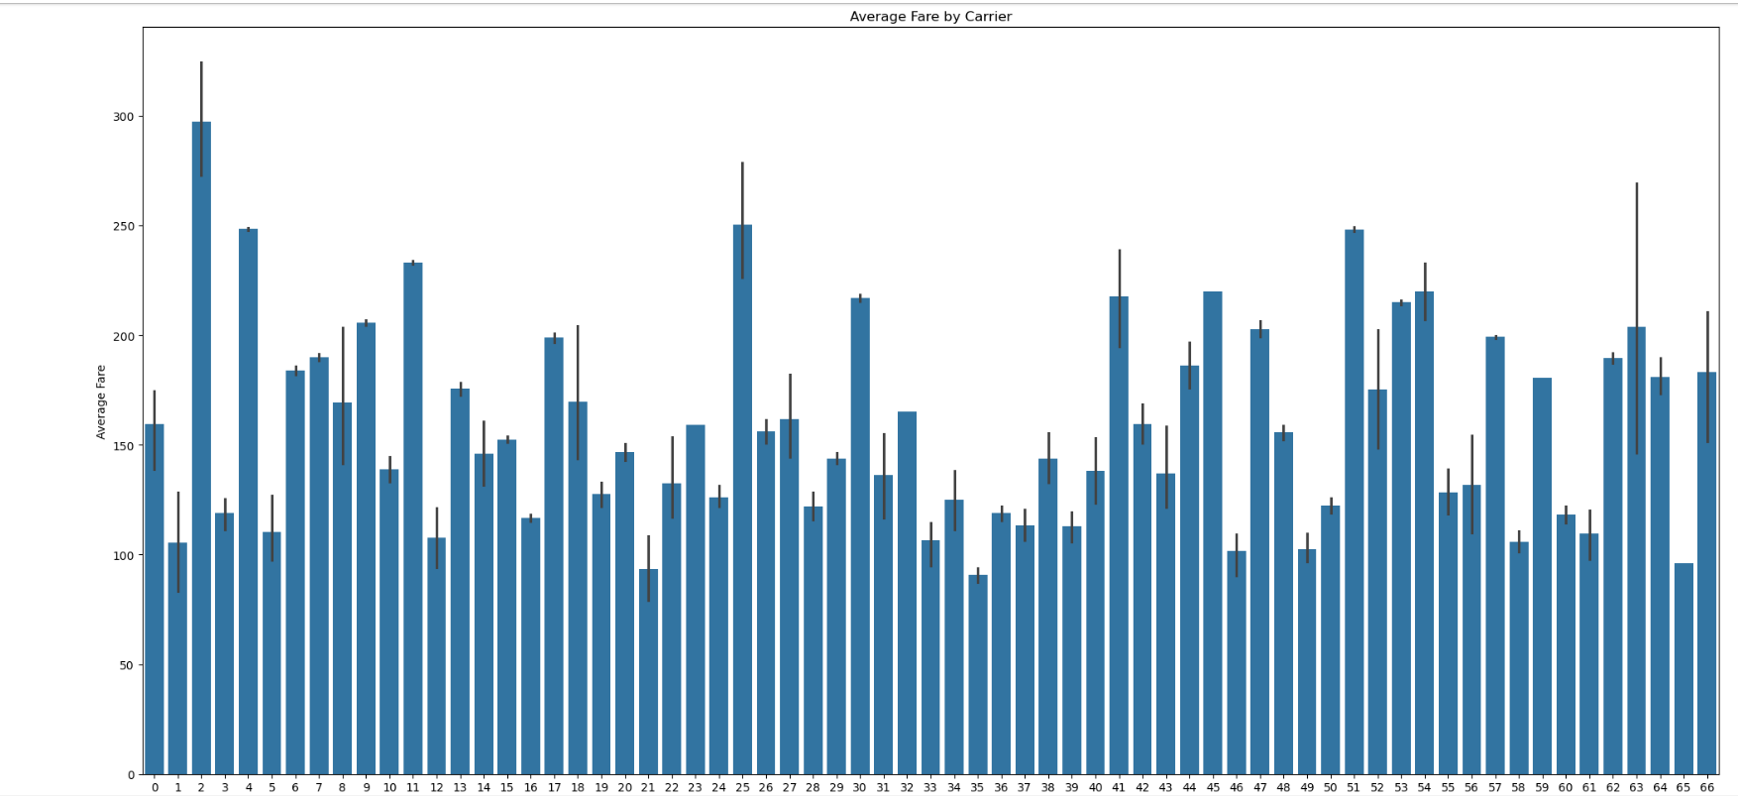

Purpose:
Shows which carriers are expensive vs. affordable
- Airlines with very tall bars → premium or expensive carriers
- Airlines with short bars → budget or lower-priced carriers

- Modeling
Regression models including Linear Regression, Random Forest Regressor, XGBoost, and Gradient Boosting are applied. Hyperparameter tuning and cross-validation ensure optimal performance. Model evaluation metrics include Mean Absolute Error (MAE), Root Mean Squared Error (RMSE), and R² score.

- Evaluation
Models are evaluated using standard performance metrics to ensure accuracy and reliability.
Key success metrics used in this project include:
- MAE (Mean Absolute Error): Measures how far predicted fares are from actual fares on average. Lower MAE indicates better accuracy.
- RMSE (Root Mean Squared Error): Penalizes larger errors more heavily, helping identify models that handle price variability well.
- R² Score (Coefficient of Determination): Shows how well the model explains variance in airfare prices. Higher values indicate stronger predictive power.
- MAPE (Mean Absolute Percentage Error): Helps understand prediction error in percentage form, making results easy to interpret.
Models are interpreted to identify the most influential features and analyze route-specific pricing patterns. Results are validated using test data to ensure the predictions are robust, generalizable, and suitable for real-world use.

REFERENCES
- Airline Fare Data Source
U.S. Department of Transportation, Bureau of Transportation Statistics.
Domestic Airline Consumer Airfare Report (Table 1A).
https://www.bts.gov/air-fares
- Industry Fare Standards
Standard Industry Fare Level (SIFL) Updates.
https://www.transportation.gov/
- Airline Statistics
U.S. Department of Transportation, Office of Aviation Analysis.
U.S. International Air Passenger and Freight Statistics Report.
https://www.transportation.gov/policy/aviation-policy/us-international-air-passenger-and-freight-statistics-report

Research Paper:

- Borenstein and Rose (1994) studied U.S. airline fares using the same DOT Origin–Destination dataset as this project. They showed that airfare mainly depends on factors like distance, competition, and the airline operating the route. This supports using features such as nsmiles, fare, carrier, airports, and city-pair markets in the model. https://faculty.haas.berkeley.edu/borenste/download/JPE94AirPrice.pdf?utm_source=chatgpt.com

- Wang et al. (2019) proposed a machine-learning framework for airfare price prediction using U.S. airline datasets such as DB1B and T-100, which contain key variables like fare, route distance, number of passengers, and carrier details. Their methodology supports the feature selection in this project, particularly the use of nsmiles, passenger count, carrier, and city-pair information for building an accurate airfare prediction model.
https://lweb.umkc.edu/chen/PDF/IRI2019_Wang.pdf?utm_source=chatgpt.com

- Prasad et al. (2020) used machine learning methods (Random Forest, XGBoost, Linear Regression) to predict flight ticket prices. Their research shows that ML is an effective approach for airfare prediction, supporting the modeling techniques used in this project.https://www.researchgate.net/publication/382607145_Prediction_of_Airline_Ticket_Price_Using_Machine_Learning_Method

Original owner of data | Office of the Secretary of Transportation, U.S. Department of Transportation
Data set information | Consumer Airfare Report: Table 1a – All U.S. Airport Pair Markets. Provides quarterly data on average fares, passenger volumes, distances, and airport pairs. Aggregated as directionless markets.
Any past relevant articles using the dataset | SkyPredict: Airfare Prediction Model" (IOSR-JCE)
Reference | BTS Consumer Airfare Report – Table 1a
Link to web page | https://catalog.data.gov/dataset/consumer-airfare-report-table-1a-all-u-s-airport-pair-markets

***********************************************************

